1. Violin Plot of Math Scores by Gender:

Description: This plot creates separate violin plots for reading scores, grouped by gender. Each violin plot represents the distribution of reading scores for one gender.
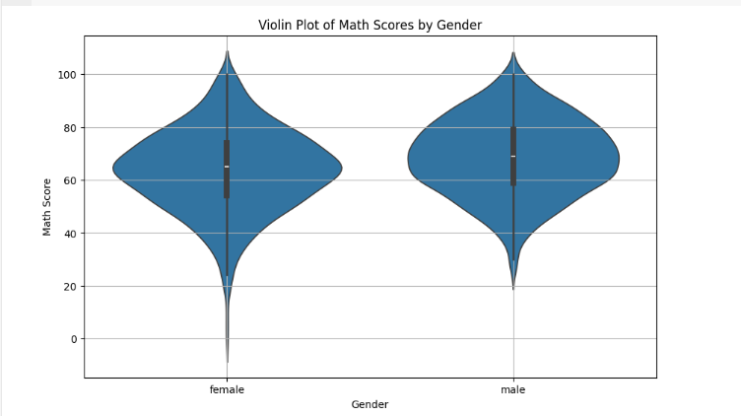

2. Joint Plot of Reading vs. Writing Scores:

Description: This plot displays a joint plot of reading scores versus writing scores, with a scatterplot of individual data points along with marginal distributions (histograms) for each variable.
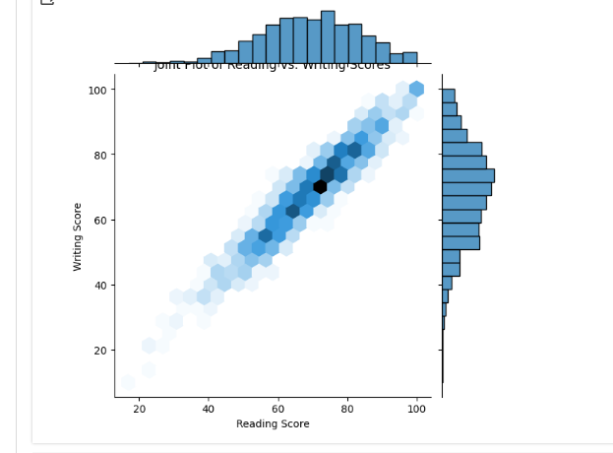

3. Heatmap of Correlation Matrix:

Description: This plot displays a heatmap representation of the correlation matrix between variables, in this case, math, reading, and writing scores. Each cell in the heatmap represents the correlation coefficient between two variables, ranging from -1 to 1.

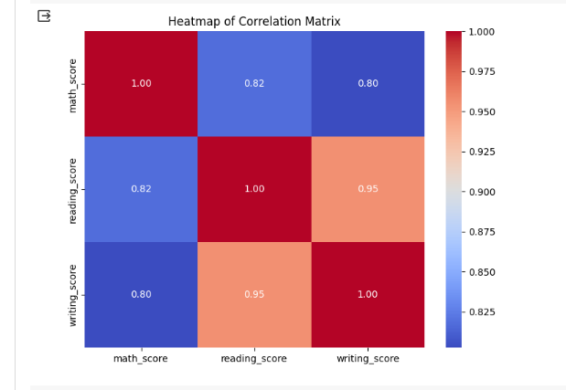

4. Box Plot with Swarm Overlay:

Description: This plot combines a box plot with a swarm plot. The box plot visualizes the distribution of the math scores for each category of parental level of education, showing summary statistics like median, quartiles, and outliers.

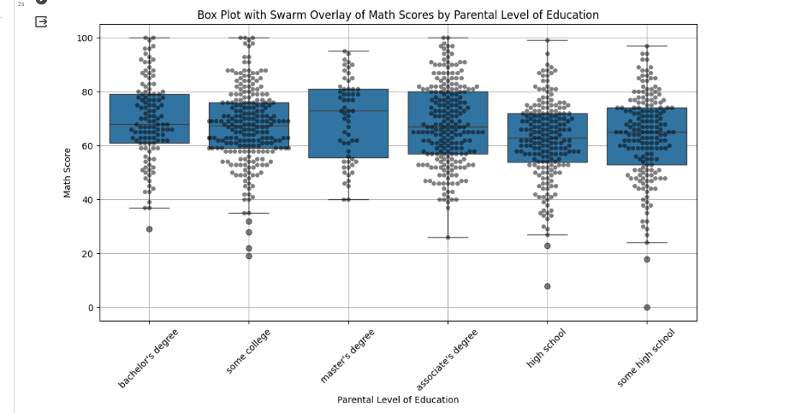

5. PairGrid of Math, Reading, and Writing Scores:

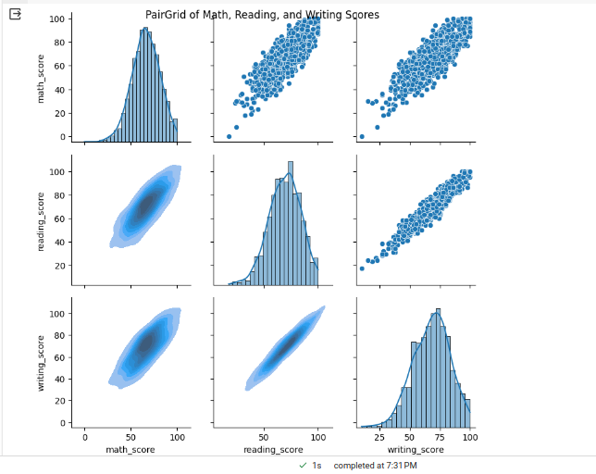
Description: This plot creates a grid of pairwise scatterplots for the numerical variables (math score, reading score, writing score) in the dataset.

6. Swarm Plot of Reading Scores by Parental Level of Education:

Description: This plot displays a swarm plot of reading scores, grouped by parental level of education. Each point in the plot represents a student's reading score, and the points are distributed along the categorical variable (parental level of education).

